**Bugs of Website**

1. **Home Page**
2. The logo should be changed.





The new logo will be –

**N.B. – Logo Image is mailed**

1. The color of the marked menu bar should be transparent, not black.



1. 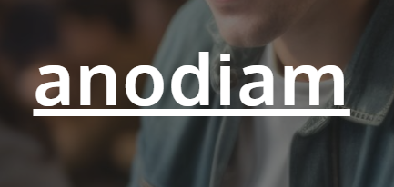

On the home page, the **anodiam** should be removed.We will give you a new background image.

**N.B. – The replacement image will be mailed**

1. Provide a login button on the header which should lead to the following url:

<https://www.anodiam.com/login>



Delete the above section as it is not required.

1. Remove the above logo which is marked inside red square
2. **USE THIS SAME FONT STYLE (Font should be Oxygen) FOR WRITING ALL PAGE HEADERS, NO UNDERLINES.**



1. The button width is too long.

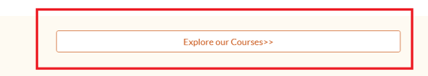

1. The tooltip text is moving up and down while scrolling for all buttons.

